NST21022 - Practical for Network Switching and Routing
Department of Information and Communication Technology
Faculty of Technology
Lab sheet :03
Reg. Number: SEU/IS/20/ICT/084
Academic Year :2020/2021
Practical No :03

Title:
- Mac addresses and Routers

Aim:
- Get to know about MAC addresses and its important
- Get to know about Router and its important

Task:
- Create a simple network and check MAC addresses
- Attach a router to the network and configure and check

Activities
Exercise 01:
1. Create a simple network with following devices and check MAC address and
configure IP addresses.
- 2 Switches
- 6 PCs
- Use suitable connection
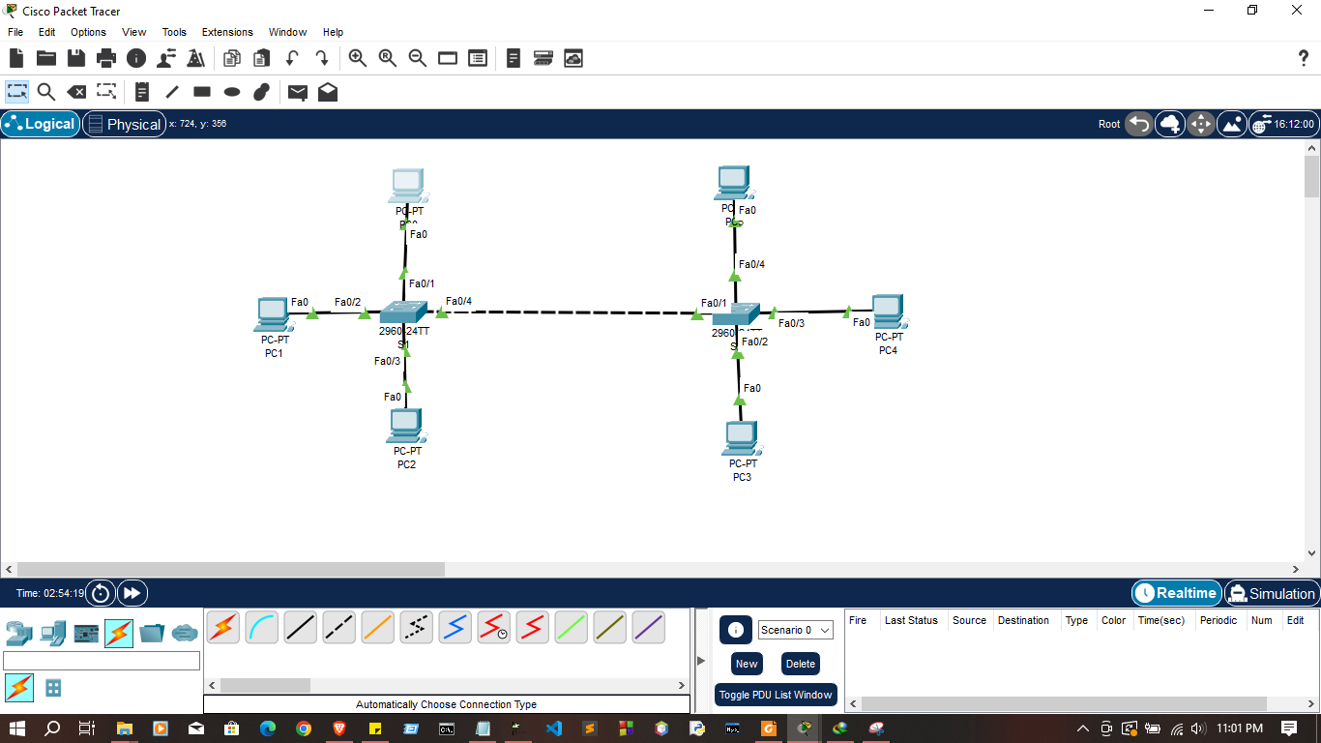

Switches 01
enable
configure terminal
hostname RegNo-S1
no ip domain-lookup
line console 0
password 1234
login
exit
enable secret class
service password-encryption
interface vlan 1
ip address 192.168.1.1 255.255.255.0
no shutdown
banner motd $

##################################################################
##################################################################

Autherized user Only
Switche1

##################################################################
##################################################################
$

exit
exit
show running-config
copy running-config startup-config
enable

Switches 02
enable
configure terminal
hostname RegNo-S1
no ip domain-lookup
line console 0
password 1234
login
exit
enable secret class
service password-encryption
interface vlan 1
ip address 192.168.1.2 255.255.255.0
no shutdown
banner motd $

##################################################################
##################################################################

Autherized user Only
Switche2

##################################################################
##################################################################
$

exit
exit
show running-config
copy running-config startup-config
enable

2. Analyze MAC address table
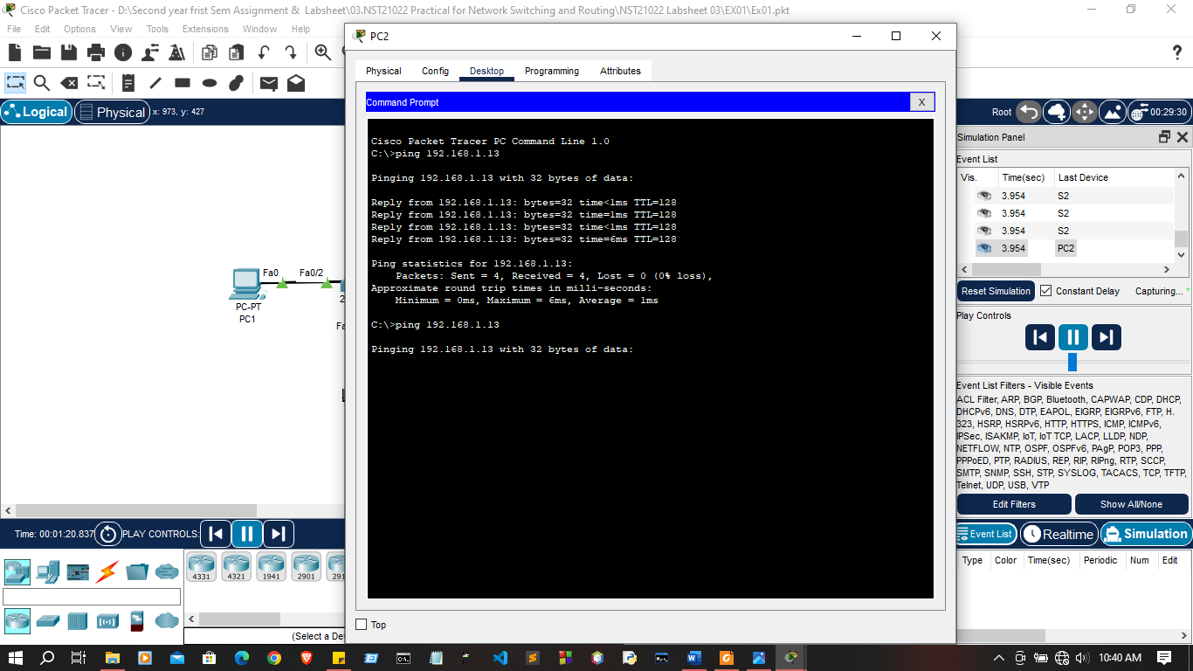
- Open simulation mode in packet tracer

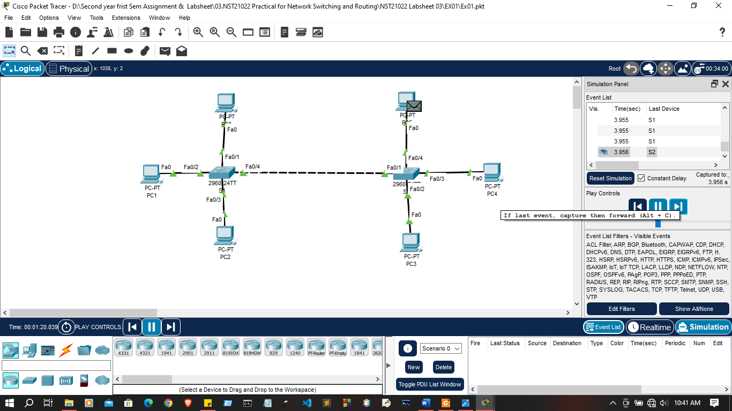

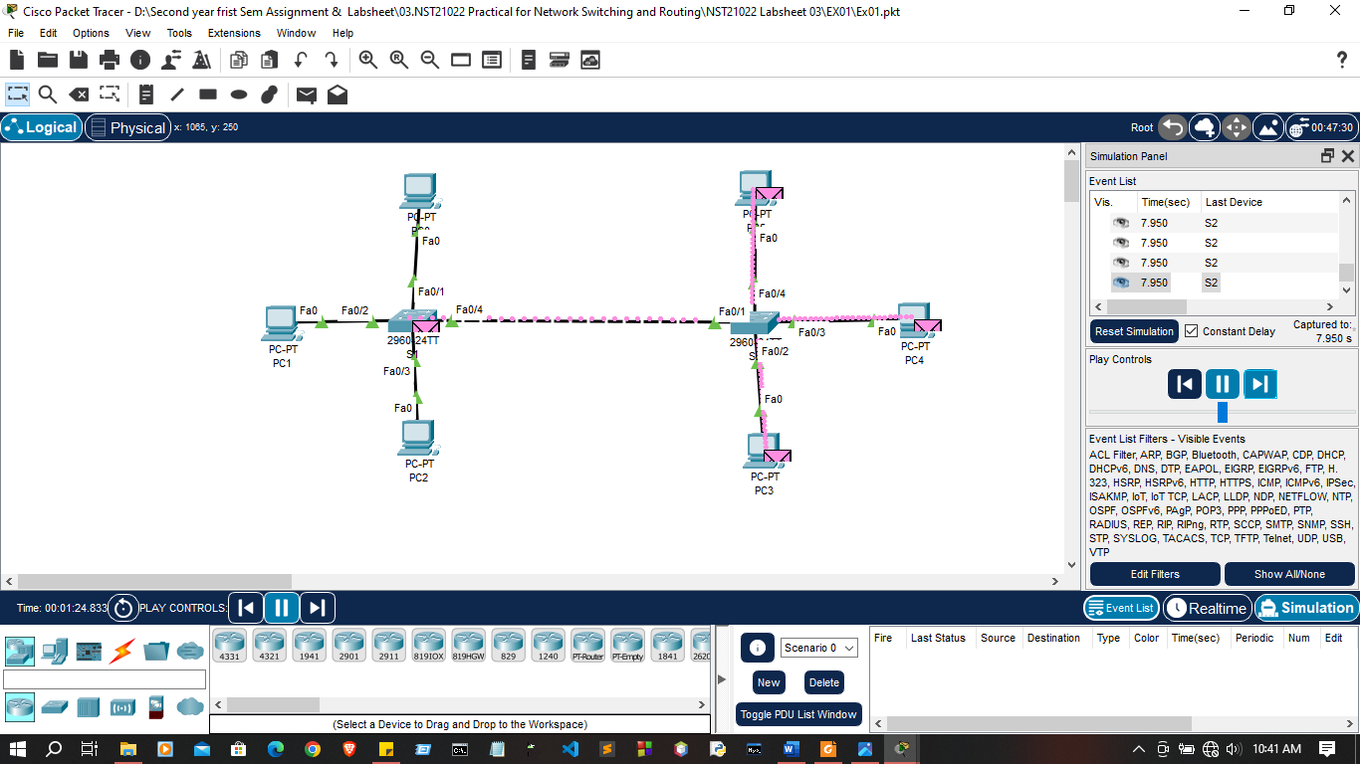

- Ty to ping from PC to another PC
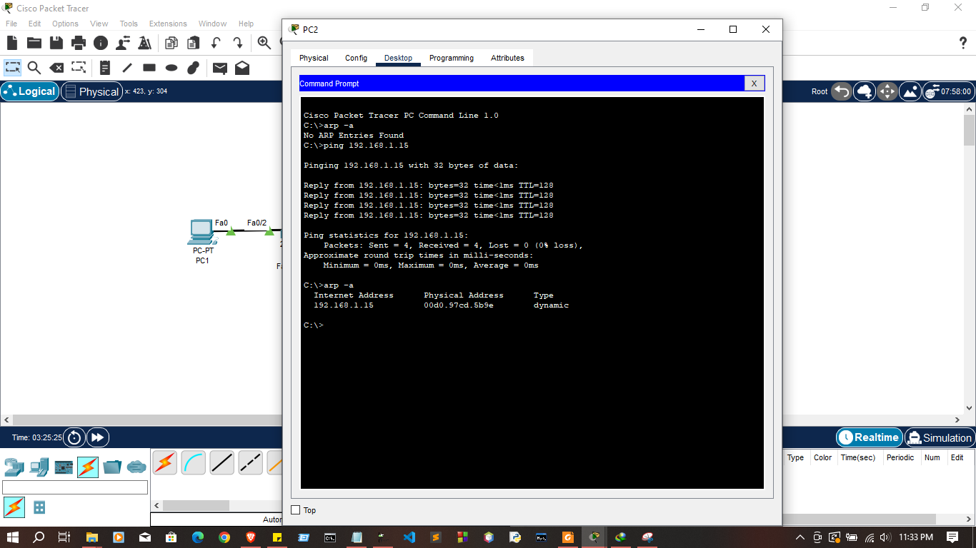

- Check ARP table in switches
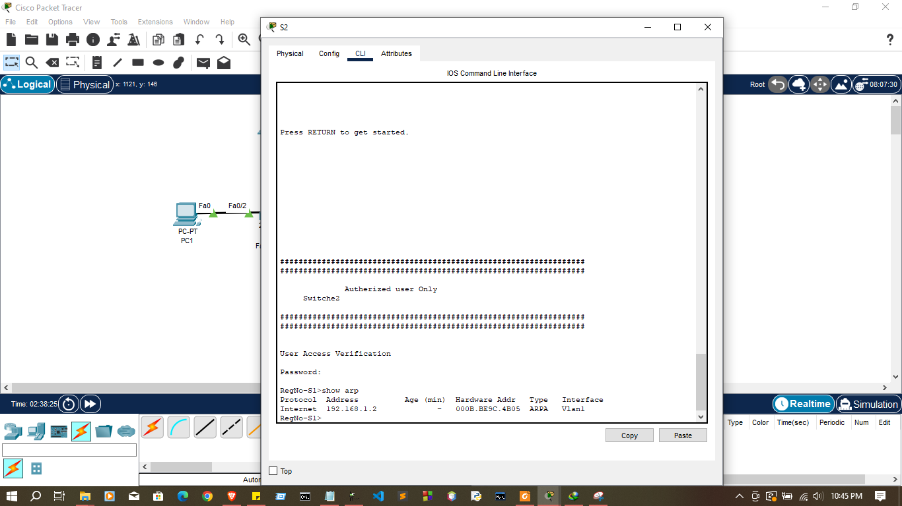
show arp
RegNo-S1>
RegNo-S1>show arp
Protocol Address Age (min) Hardware Addr Type Interface
Internet 192.168.1.1 - 0060.4763.DE8C ARPA Vlan1
RegNo-S1>

- Check MAC address table in switches
show mac-address-table

User Access Verification

Password:

RegNo-S1>show mac-address-table
Mac Address Table
-------------------------------------------

Vlan Mac Address Type Ports
---- ----------- -------- -----

1 0050.0f76.0162 DYNAMIC Fa0/3
1 0090.0c84.edb8 DYNAMIC Fa0/4
1 00e0.a376.e501 DYNAMIC Fa0/4
RegNo-S1>
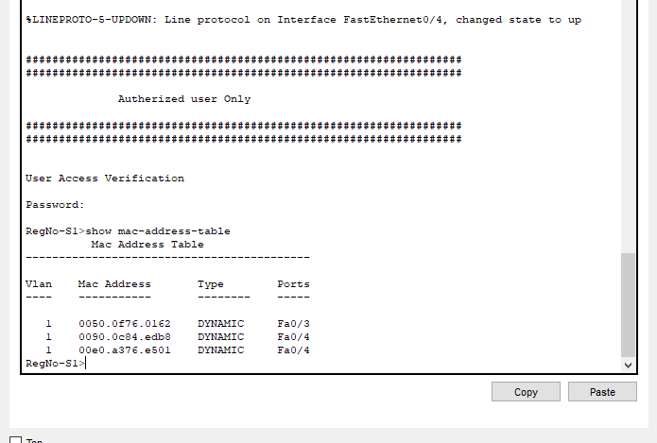
- Check ARP table in PCs
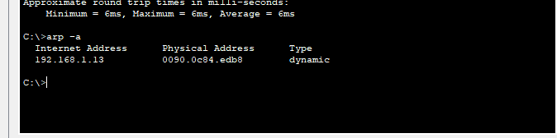
arp -a

C:\>arp -a
Internet Address Physical Address Type
192.168.1.13 0090.0c84.edb8 dynamic
Exercise 02:

Devices | Interfaces | IP Addresses | Subnet Mask
R1 | g0/0/0 |  | 255.255.255.0
  192.168.1.1
R1 | g0/0/1 | 192.168.2.1 | 255.255.255.0
PC-1 | NIC | 192.168.1.3 | 255.255.255.0
PC-2 | NIC | 192.168.1.4 | 255.255.255.0
PC-3 | NIC | 192.168.2.3 | 255.255.255.0
PC-4 | NIC | 192.168.2.4 | 255.255.255.0

1. Configure a simple network with following devices
- 1 Router
- 2 Switches
- 4 PCs
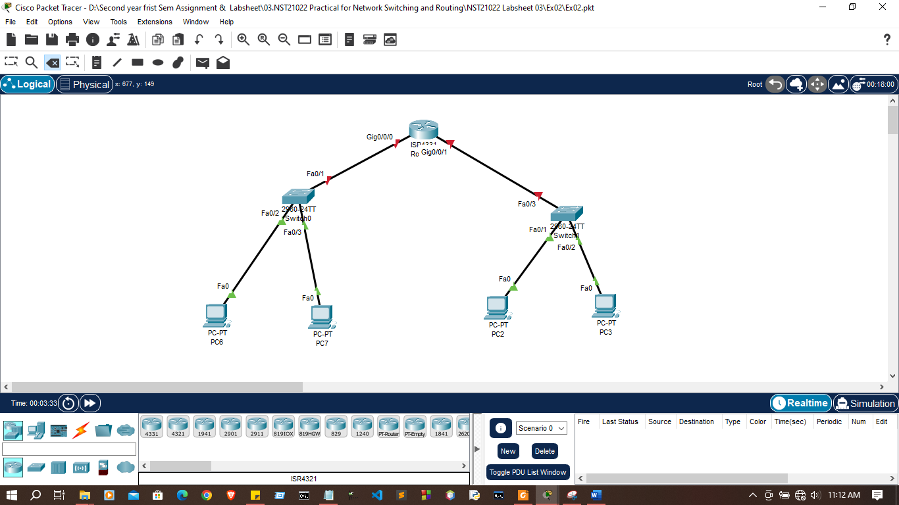

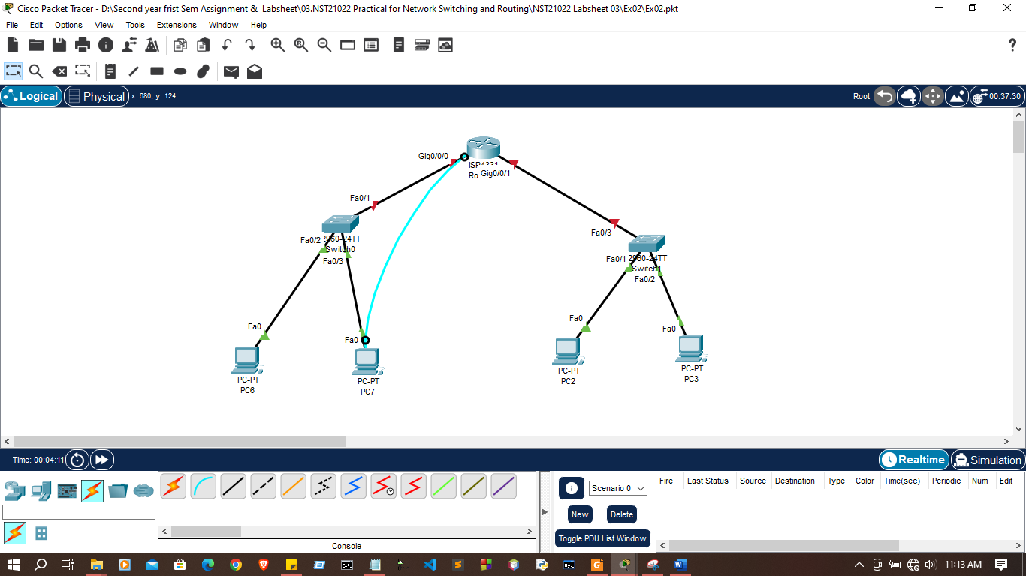
2. Configure basic configuration on router through console cable.

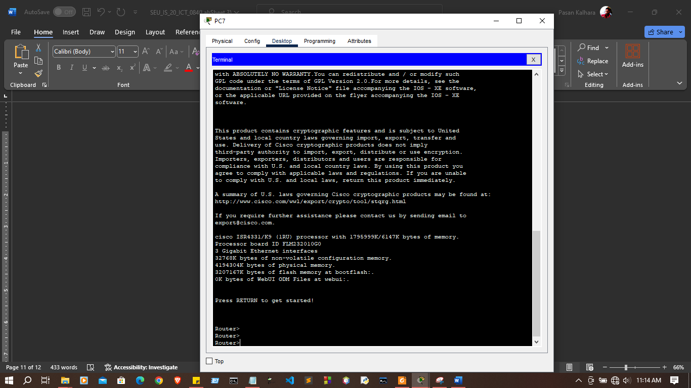
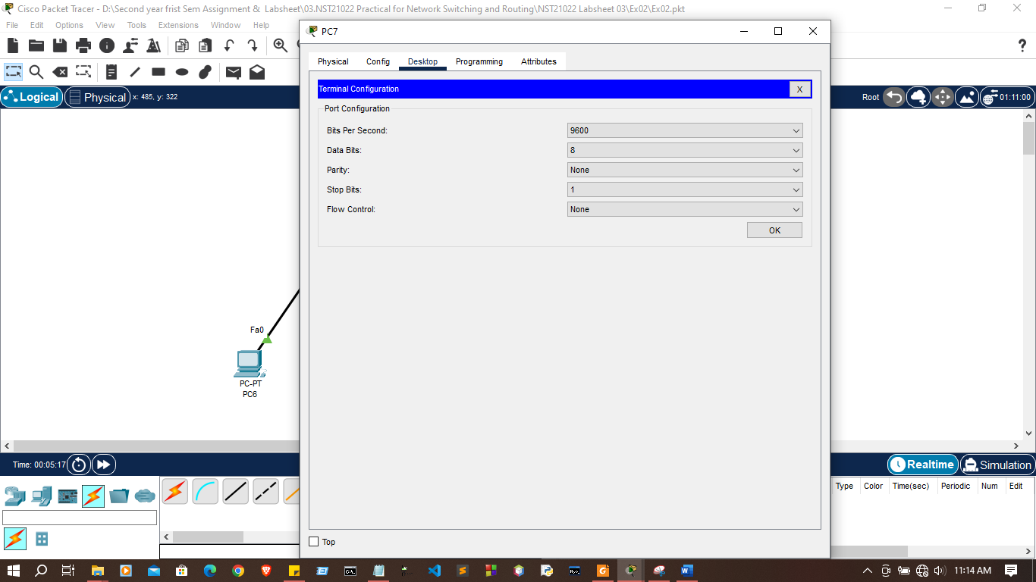

- Configure hostname

Router>enable
Router#configure terminal
Enter configuration commands, one per line. End with CNTL/Z.
Router(config)#hostname R1
R1(config)#

- Prevent unwanted DNS lookup

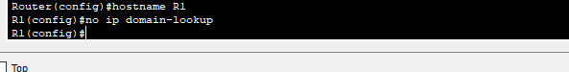

- Configure password protection to console line

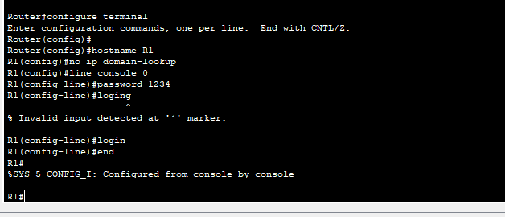

- Configure password protection to privileged EXEC mode

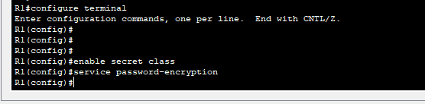

- Encrypt all password

- Assign IP addresses to the interfaces according to the addressing table

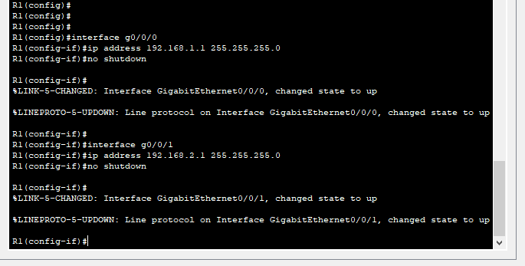

- Configure proper banner message

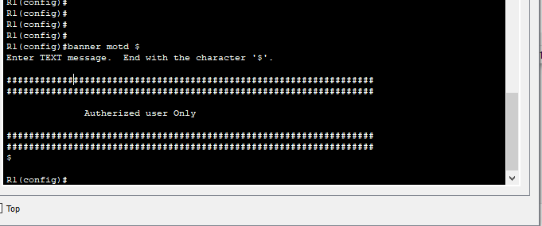
- Save configurations
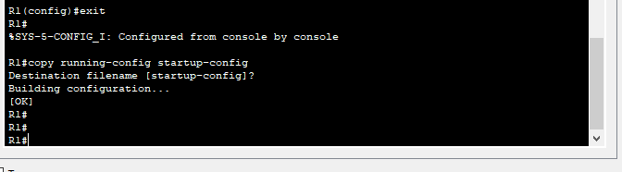

3. Verify running configurations on router
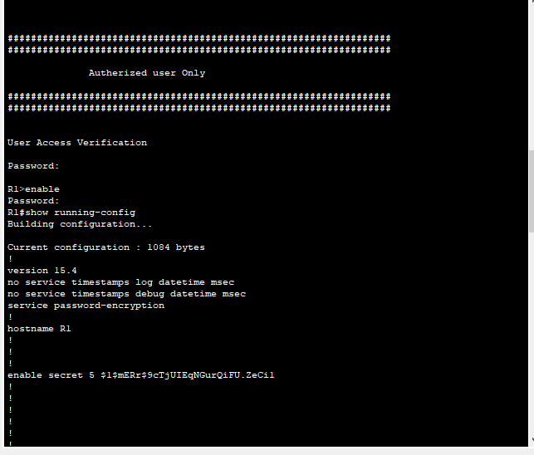

4. Try to ping between PCs
If pinging not success discuss and find a solution
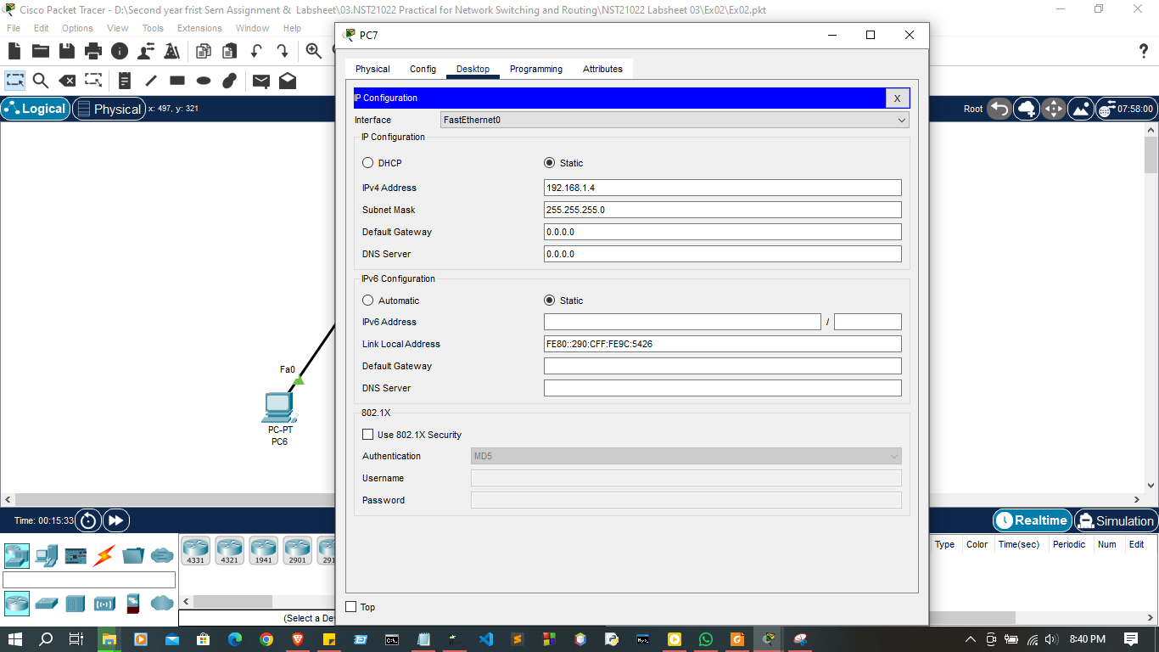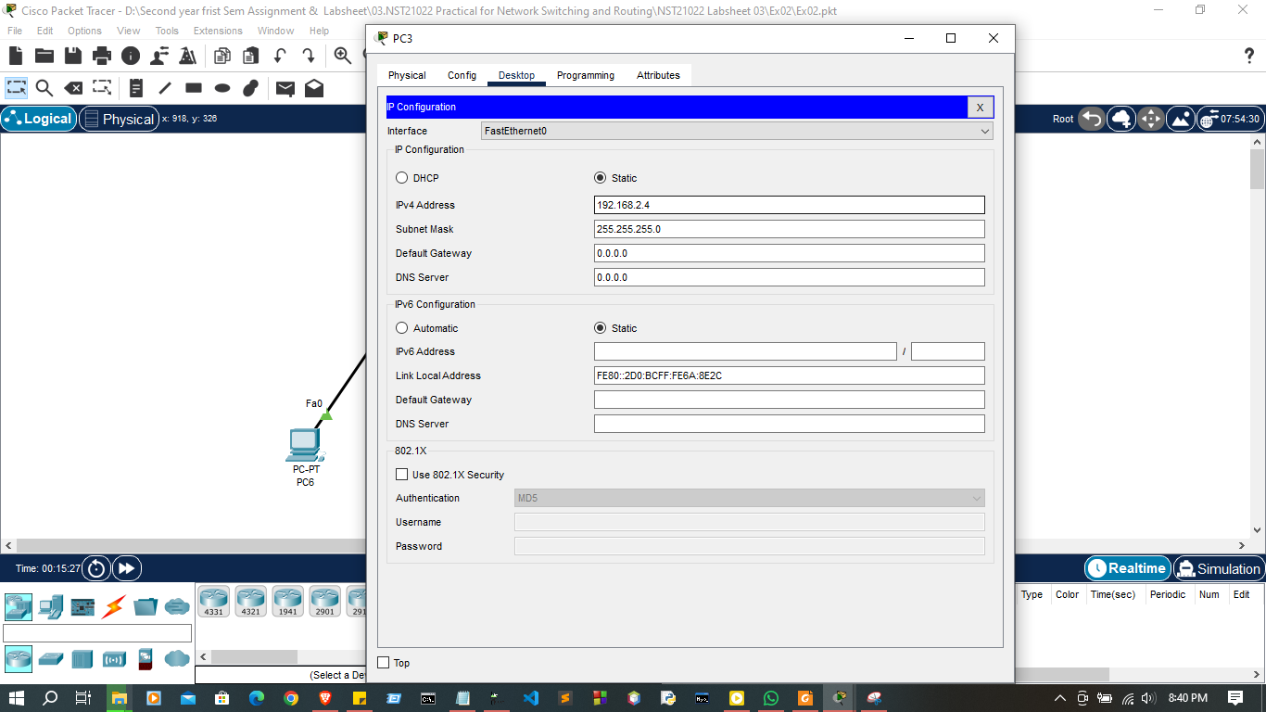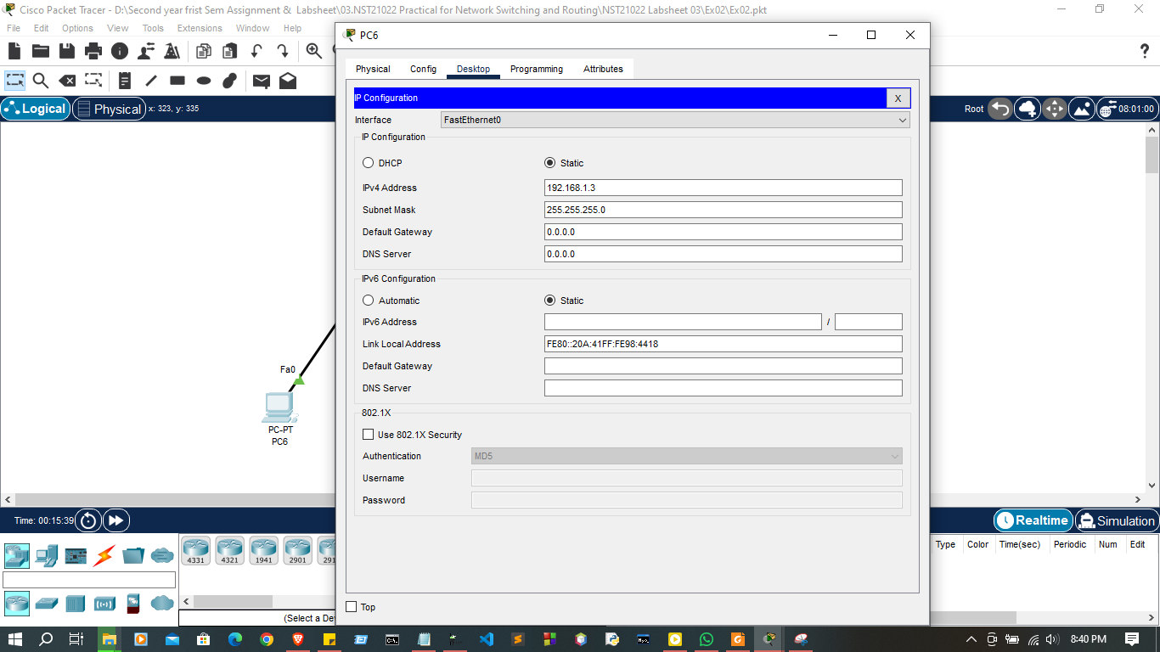
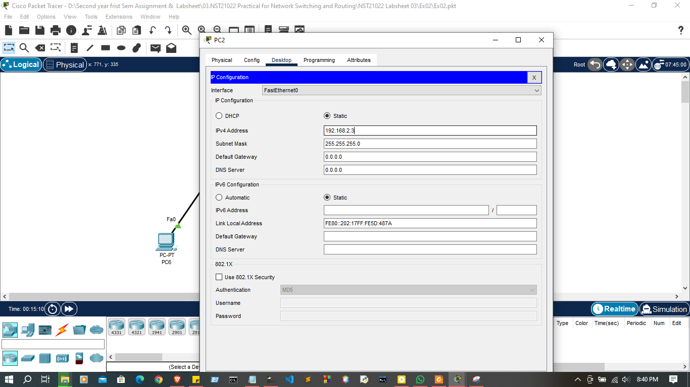
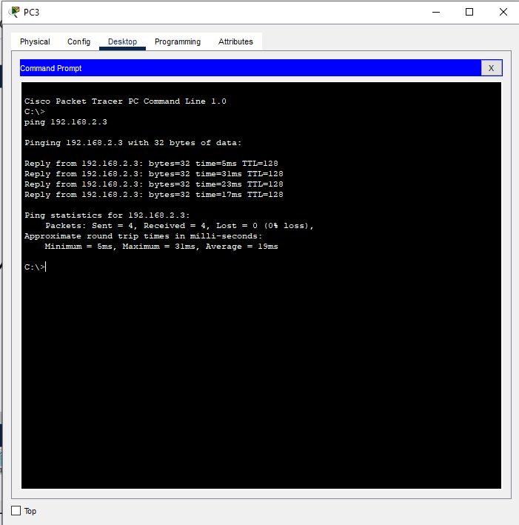

Discussion:
- In this lab session, we focused on understanding the significance of MAC addresses and routers in a network. First, we created a simple network consisting of devices like PCs and switches, and checked the MAC addresses of each device, recognizing that MAC addresses are unique identifiers for network interfaces and essential for communication at the data link layer. Next, we introduced a router to the network to facilitate communication between different networks. We configured the router with basic settings, such as IP addressing, and tested connectivity between devices. This session helped us understand the critical role of MAC addresses in device identification and how routers enable communication across different networks.

